**TITLE:**

Latent phenotypic complexity of adaptation in a single environment

**AUTHORS:**

Grant Kinsler, Dmitri Petrov, Kerry Geiler-Samerotte

**AFFILIATIONS:**

**INTRODUCTION** [Not really changed from Kerry’s original]

# **Paragraph One: Adaptation is awesome, but it shouldn’t be.**

# Single punchy (less technical) sentence that captures main idea of paper:

# Organisms have an amazing ability to adapt to diverse challenges, yet recent observations suggest most mutations affect many traits and most of these effects are deleterious. How is adaptation possible if mutants that influence one trait in a beneficial way influence many other traits in a deleterious way?

* 1. We know it is indeed possible: examples of adaptation’s awesome power
     1. Ben Good showing that microbes never run out of adaptive mutations
     2. Which other examples?
  2. But how is adaptation possible? Conclude by defining the ‘cost of pleiotropy’ and explaining that the more pleiotropy there is, the greater the constraint on adaptation.

1. **Section Two: How much pleiotropy is there and why is it so hard to find out?**
   1. Long history of debate on this topic.
      1. Is pleiotropy omnigenic/universal or modular? If modular, by learning relationships among traits one might be able to predict which suites of traits are jointly influenced by genetic changes.
      2. Though modularity seems reasonable and many studies suggest cellular systems have a modular organization, GWAS studies detect ungodly amounts of pleiotropy suggesting every gene has the potential to influence every trait.
   2. This debate persists because of challenges defining and measuring phenotypes, and integrating information about phenotypes at different levels of biological organization
      1. There are too many phenotypes, potentially millions or an infinite number depending on how creative you are
      2. Phenotypes are often related, effects cascading through levels of biological organization, introduce genotype-phenotype-phenotype map idea
   3. Conclude by explaining the ‘impossible task’: Quantifying all of these traits and enumerating relationships between them to understand which suites of traits (or whether every trait) will be jointly influenced by a mutation is too much work.
2. **Section three: Clever solutions leveraging barcoding**
   1. We have a new approach to understanding the extent of pleiotropy among adaptive mutations that circumvents the problem. We do not measure any of these phenotypes, instead we repeatedly measure fitness.
   2. Briefly explain the idea in general terms, subtle perturbations
   3. Explain the large data set we will use to test the idea, and how this is only possible because (1) these strains are barcoded, (2) NGS gives us lots of power to measure fitness, and (3) we cleverly use information about fitness to learn something about phenotypes.
3. **Section four: What do we find? Punchlines**
   1. Subtle perturbations reveal the structure of phenotypic responses for our collection of mutants
      1. This space can predict fitness of new mutants in new, stronger environmental perturbations
      2. Mutants that otherwise were expected to have similar phenotypic responses (GPB2 and PDE2) in fact have distinct ways in which they interact with the environment
      3. The behavior of these mutants in the subtle perturbations is well-described by a few (4) phenotypic components
   2. There are specific, latent phenotypes that have minimal importance in subtle perturbations that have large predictive power in particular strong conditions.
      1. These phenotypes reflect particular behaviors of particular mutants
   3. Our method is really cool.
      1. Talk about all the cool things you could learn using this epic approach.

**RESULTS**

**Section 1: A method to identify fitness-relevant phenotypes**

1. Intuition: organism’s phenotype determines its interactions with environment and thus fitness. So by measuring fitness in different environments, we can learn about these interactions at start getting towards the important phenotypes
   1. Solidify this intuition with explicit discussion of SVD model.
   2. Identifying the complexity of phenotypes is difficult and involves selecting the proper model. This overfitting issue is a common statistical problem.
2. In simulation, we can identify phenotypic components using two procedures:
   1. Bi-cross-validation (talk about the procedure)
   2. Simulating noise matrix and doing SVD on this
3. Identifying fitness-relevant phenotypes relies on measurement precision, with more precision, you can detect more smaller signals.
4. Hint at latency stuff/idea

**Figure 1. [TBD]** Intuition for the SVD method, noise vs. signal, cross-validation procedure, simulations showing it works, building intuition for “latent phenotypes” [probably some supplemental figures to accompany]

**Section 2: Barcodes allow us to measure and detect differences between subtle environmental perturbations**

1. Mutants from the evolution experiment. Most are from nutrient-response pathways and/or diploidy.
   1. RAS/PKA mutants – are they adaptive for the same reason? do they exhibit the same phenotype in the evolutionary condition?
2. Barcodes allow us to measure the fitness of these mutants in a large collection of environments. We’re particularly interested in subtle environments, but it’s not clear what that is.
3. Barcodes let us measure fitness remarkably well.
   1. IRA1 spike ins cluster in replicates, replicates are more similar than batches [Fig S1A]
   2. Despite this, there are batch effects! [Fig S1B]
4. This measurement precision allows us to see a lot of variation across our collection of environments – some are subtle and some very much not subtle [Fig 2]
   1. Lots of possible signal here to learn about phenotypes!
   2. From fitness alone, it’s clear that fitness isn’t the whole story – there must be additional features that are important to the data. [some examples…]
   3. It’s also clear from the strong perturbations that particular mutants have different effects that aren’t obvious in M3 [GPB2, PDE2] – is this also true when we look at their behavior in the subtle perturbations?



**Figure 2. Measuring fitness for a collection of adaptive mutants across many environments has the potential to reveal real biological signal. (A)** Conditions are ordered based on similarity to the average across all batches. Conditions where the balanced recurrent mutations are less than two standard deviations different from the evolved condition are denoted in black and make up the subtle perturbation set. Conditions where the aggregate behavior exceeds two standard deviations are shown in red and make up the strong perturbations. **(B)** For each mutation type, we take the average fitness across the evolution condition batches and the standard deviation of this behavior –Shaded regions represent two standard deviations away from the mean amongst the batch conditions per mutation type. On the right are kernel density estimates for the distribution of each mutation type across all conditions (two standard deviations around batches are shaded).

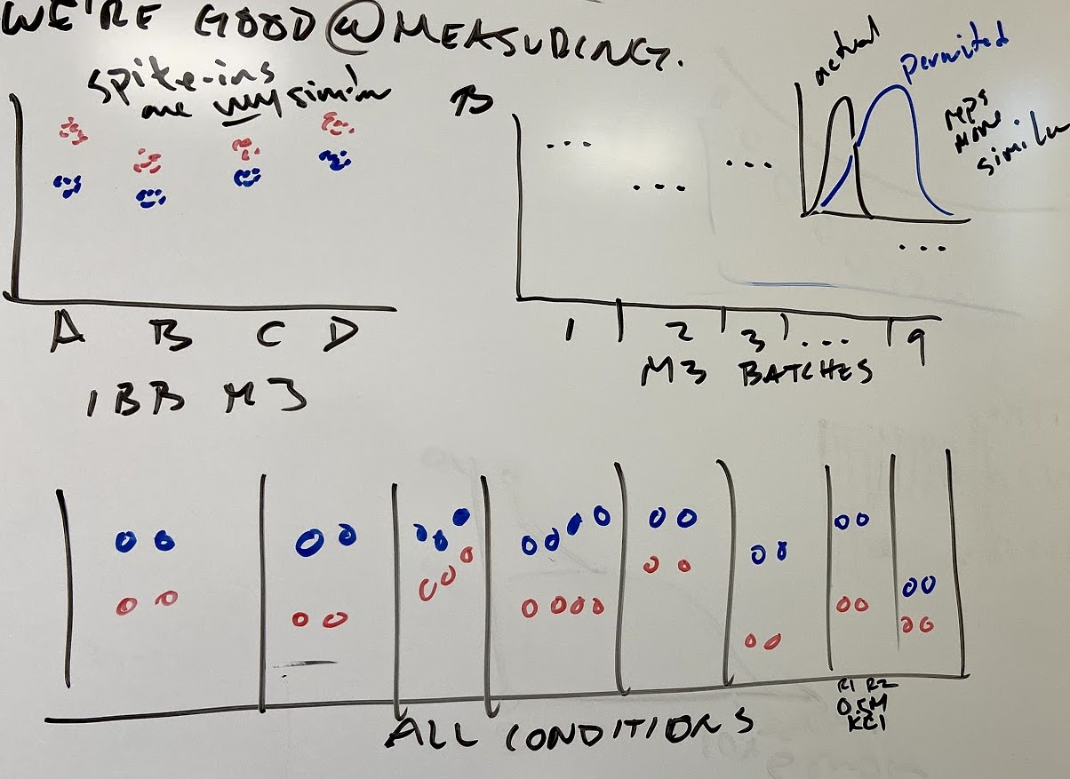

**Fig S1. We’re good at measuring things. (A)** Very little variation within flask for spike-ins labeling the same mutation. **(B)** Replicates within the same batch are more similar to each other than batches. **(C)** Showing all the replicates for all the non-batch conditions.



**Fig S2. M3 fitness doesn’t explain all the signal.** The relationship between average fitness in M3 and fitness in the rest of the conditions. There are intricate patterns of relationship across these conditions, indicating that the evolution condition fitness is not the only determinant of fitness across these perturbations.

**Table 1. All mutants included.**Show number of mutants, including number included in canonical training and test sets.

**Table S1. All conditions.** Detailed account of all the conditions used. Include batch number/date done, glucose conc., extras conc, flask used.

**Section 3: Phenotypes relevant to subtle perturbations have predictive power in strong environmental perturbations.**

1. Using SVD and our approaches to identify the number of components, we detect 9 fitness-relevant phenotypes from our collection of mutants in subtle environmental perturbations.
   1. However, with only 4 of these components we explain 95% of variation. The additional 5 each contribute less than 1% to explanatory power.
2. From the space constructed with subtle perturbations, we can accurately predict fitness in the strong perturbations, indicating we are learning about real biological signals
   1. Note, as we saw from the data alone, a single component (which is highly correlated with mean fitness in M3) does poorly.
   2. With 4 components, we do a very good job for most conditions (baffle, 1.8%, benomyl, 7 day)
   3. The additional minor phenotypes have strong effects in particular conditions (1 day, suc/raf, 2.5%, 4day, 6day)



**Figure 3. 9-component model can accurately predict fitness of held-out mutants in strong conditions.** **(A)** Predictions from the 9-component model (red circle) are typically better than the 1-component mode (open circle) and the average of 1000 permutations (black line, each permutation shown in gray). The 4-component model (black dot) has similar predictive power for most conditions. However, particular conditions (1-, 4-, 5-, 6-Day, Baffle + 2.5% Glucose, and 1% Sucrose/Raffinose) gain significant predictive power from the additional 5 minor components. **(B)** Comparison of predictions of the 1-, 4-, and 9- component models for all held-out mutations in Baffle + 1.8% Glucose,1 Day, 1% EtOH, Baffle + Benomyl, and 0.5M NaCl conditions. **(C)** Conditions with particularly strong gains have much larger added variance explained from the 7th, 8th, and 9th components than the subtle and the other strong conditions. Note that ${\tilde{R}}^{2}$ less than zero indicates that the prediction is worse than using the mean fitness in that condition and that ${\tilde{R}}^{2}$ is weighted according to the number of each mutation type present in the held out data (see Methods for details). **(**Points in **(B)** colored by the mutation type. For a full set of prediction comparisons see Supplement. Gray and white background in **(A)** for eye-guiding purposes only.



**Fig S3. We detect 9 components with subtle perturbations. (A)** SVD on noise-only matrix detects 9 components. **(B)** Bi-cross validation also detects 9 components. **(C)** Strong perturbations best predicted by 9 components. **(D)** Added Weighted VE in subtle and in strong perturbations for test mutants. Slight increase in contribution of component 4 over 3 and 8 over 7 for subtle perturbations is due to use of weighted variance explained rather than raw variance explained that SVD optimizes on.

**Fig S4. Robust to choice of mutants.**

How robust are these results to our choice of mutants? 1) inference of 9 components, 2) predictive power, and 3) the “latent” phenotype idea

**Fig S5. Figure without weighted R^2?**

**Fig S6. All 1-, 4-, 9- component comparisons by condition. (for all of them).**

**Section 4: Adaptive mutants have general, shared phenotypic responses, with specific, latent phenotypes**

1. The space reveals the phenotypic structure of mutants.
   1. Genes have meaning (mostly)
      1. Diploid, PDE2, GPB2 cluster together – [some PDE2 outliers]
      2. IRA1 does not cluster together
      3. IRA1 nonsense *does* clustertogether (except for a couple interesting exceptions that are particularly affected by Baffle conditions)
   2. Mutants we thought would be similar but are different
      1. GPB2 + PDE2
      2. Interesting IRA1 mutants
   3. Mutants we thought would be different but are similar
      1. ???
   4. TOR mutants scattered
   5. Class of adaptive diploids with no known additional non-synonymous mutations

**Some kind of statistical test/permutation type for how unexpected “latent” phenotypes are?**

*It seems pretty clear that dimensions 5 + 6 are mostly “noise” (i.e. genes are pretty spread out) – is this problematic/how should we address this? – I don’t think it’s necessarily damaging to the latent phenotype idea since it does have much larger contribution than in subtle, but it might mean that “dimension 7” is really something more like “dimension 5” in terms of real signal. This also makes it such that figures with 4 dimensions are much better at representing differences between mutants (i.e. IRA1 nonsense) that seem to be really different (visually)*



**Figure 4. The phenotypic space of interactions reveals real biological features of mutants. (A)** UMAP showing mutants and their relationship. Note that this is for visualization purposes only. (**B)** Mutants close to their geometric median of their mutation type. **(C)** show specific similarities and differences – best way? **(D)** show something similar for conditions?



**Fig S7. Outlier mutants have differential fitness across many environments. (A)** Fitness of IRA1 nonsense mutants substantially further from the Geometric Median than the rest of the IRA1 nonsense mutants in all conditions. In addition to the subtle behavior that drives the detection of these mutants, they have substantial differences from the remaining IRA1 nonsense mutants in strong perturbations. **(B)** Same as **(A)** for PDE2 mutnats.



**Fig S8. The space – all pairs of components (mutants AND conditions).**



**Fig S9. Hierarchical clustering of mutants. (A)** Clustering of mutants using Ward’s method with 4-component model. (B) Clustering of mutants using Ward’s method with 9-component model.

1. Latent phenotypes are driven by particular environmental interactions of particular mutants
   1. 1,4,5,6 Day mutants in 7th component
      1. GPB2
      2. Diploid w/ chr 11 amp
      3. SSK2



**Figure 5. Particular mutants have specific, latent phenotypes that are important in 1-, 4- ,5- ,and 6-Day conditions. (A)** Contribution of each component to predictive power in subtle, strong, “interesting” conditions. **(B)** Space with Component 1 vs. Component 7 - it reflects a particular difference of GPB2 (and some other mutants). **(C)** Number of standard deviations improvement by condition in 1 Day condition (-3 means better by 3 standard devations) from addition of the 7th component. **(D)** Number of standard deviations improvement by condition in 4 Day condition (-3 means better by 3 standard devations) from addition of the 7th component.



**Fig S10. Individual mutant improvement in interesting conditions with minor components. (A)** 5 Day improvement from adding 7th component. **(B)** 6 Day improvement from adding 7th component.



**Fig S11. Testing “specific latency” hypothesis – if we remove mutants utilizing this extra component, do we suddenly go back to 4 being good enough? 1 Day contribution. (A)** With all mutants **(B)** With top 4 mutants (SSK2, IRA1 nonsense, Diploid + Chr 11 Amp) removed. **(C)** Also with GPB2 mutants removed.

**DISCUSSION [just some ideas right now]**

A new approach and tool that could be useful for:

* Ecology – identifying functional units using perturbations
* Identifying the casual lower-level molecular phenotypic changes by mapping those to our components
* ???

Context dependency:

- changing environments (has particular consequences for particular mutants)

- epistasis (these aren’t truly “redundant” mutants.. how does this play out in the home environment or elsewhere?)

Dependency on this evolution experiment:

* Are latent phenotypes generically observed across evolution to other environments?
* How do more complex environments affect this result?

Importance of precision of measurement:

* With less precision, we wouldn’t detect the latent phenotypes in the subtle perturbations.

Importance of subtlety:

* Do we get the same result if we were to use the strong environments? Why is subtlety important?

**Fig S9. Measurement precision allows us to detect latent phenotypes.** If we simulate less precise measurements, we see that we only detect 2-4 anyways…

**Fig S10. Why subtle?** What does doing SVD on ALL conditions give us? Why is subtlety important?

**METHODS**

**Estimating dimensionality using noise-only SVD detection.**

To estimate the number of components to include in the model using noisy data,

**Bi-cross validation.**

**Simulating phenotype space.**

**Fitness Measurement details.**

**Condition details.**

**Calculating Weighted Coefficient of Determination**

**Calculating Weighted Average Z Score**

**Table S1: Massive table of conditions.** Detailed table with all conditions, batch number/date done, glucose concentration, drug concentration, etc.

**REFERENCES**